**19CSE435**

**COMPUTER VISION**

**Case Study Report**



**Project Title:**

**Traffic Density Analyzer**

(Given a set of videos/images of video footage categorize the density of vehicles in road)

**Member Detail (Group 7_1)**

|  |  |  |
| --- | --- | --- |
| **Roll No** | **Name** | **Contribution (Provide the headings that has been contributed by the student & Code level, Dataset)** |
| CB.EN. U4CSE21004 | Ajay Raj | Dataset, Evaluation / Result analysis, Yolo Implemented, Key Frame extraction, Literature Survey |
| CB.EN. U4CSE21045 | Praveen | Dataset, Image Processing Techniques, Dataset, Edge Detection, Literature Survey |
| CB.EN. U4CSE21047 | Reshiha | Methodology Overview, Camera Related Properties, Classifiers for recognition, Literature Survey |
| CB.EN. U4CSE21063 | Vinay Kumar | Methodology Overview, Feature Detection and Matching, Optical Flow Algorithm , Literature Survey |

1. **Problem Statement**

Given a dataset comprising videos/images of road footage, the objective is to design and implement an algorithm to categorize the density of vehicles present on the road.

1.Detecting and localizing vehicles within the images or frames of the video.

2.Implementing a counting or density estimation algorithm to quantify the number of vehicles present in each area of the road.

**Broad Objective**

The broad objective of this project is to develop a robust and efficient algorithm capable of categorizing the density of vehicles on the road from a dataset of videos or images. This involves accurately detecting, localizing, and quantifying the number of vehicles present in each frame or image. The goal is to provide a comprehensive solution that can be utilized in various applications, such as traffic management, urban planning, and intelligent transportation systems, by offering reliable data on vehicle density in real-time

**Specific Objectives**

1. **Vehicle Detection and Localization**

Develop an algorithm to accurately detect and localize vehicles within each frame or image of the dataset. This involves identifying the presence of vehicles and their exact positions within the images or video frames

1. **Counting and Density Estimation**

To quantify the number of vehicles, present in each designated area of the road. This requires the development of a method to segment the road into various zones and accurately count the vehicles in each zone.

**Questions and solutions**

|  |  |  |
| --- | --- | --- |
| **S No** | **Challenge/Question** | **Solution / Approach** |
| **1.** | Lighting and Weather Conditions | Adaptive Image Enhancement |
| **2.** | Occlusions and Obstructions | Multi-Camera Systems |
| **3.** | Diverse Vehicle Types and Sizes | Multi-Class Classification |
| **4.** | Complex Road Geometries | Geometric Mapping |
| **5.** | Camera Limitations and Positioning | Optimal Camera Placement |
| **6.** | Real-time Processing and Scalability | Edge Computing |
| **7.** | Data Quality and Annotation | Data Annotation |

**B. Dataset Detail [drive URL]**

**Benchmark Dataset**

These datasets include images captured under different weather conditions, lighting, and traffic scenarios, making it suitable for real-world applications**.**

|  |  |  |  |  |  |  |
| --- | --- | --- | --- | --- | --- | --- |
| **S.no** | **Dataset Name** | **Total No of Frames** | **Resolution** | **Environment** | **Colour** | **Image/Video format** |
| **1.** | [**Traffic Detection Project**](https://www.kaggle.com/datasets/yusufberksardoan/traffic-detection-project) | **6633** | **640x640** | **outdoor** | **all** | **.jpg** |
| **2.** | [**Top-View Vehicle Detection Image Dataset**](https://www.kaggle.com/datasets/farzadnekouei/top-view-vehicle-detection-image-dataset) | **626** | **640x640** | **outdoor** | **all** | **.jpg** |

**Custom Dataset**

**Image Data**

The image dataset comprises a diverse collection of road footage captured under various conditions, including different times of day, weather scenarios, and traffic densities

|  |  |  |  |
| --- | --- | --- | --- |
| **Category** | **Description** | **Quantity** | **Format** |
| Daytime Images | Images captured during the daytime under clear weather conditions | 20 | JPEG, PNG |
| Nighttime Images | Images captured at night, including well-lit and poorly lit conditions | 15 | JPEG, PNG |
| Weather Variations | Images taken during different weather conditions (rain, fog, snow) | 10 | JPEG, PNG |
| Traffic Densities | Images representing various traffic densities (low, medium, high congestion) | 15 | JPEG, PNG |
| Diverse Angles | Images captured from different angles and perspectives (e.g., aerial, side) | 5 | JPEG, PNG |

**Video Data**

The video dataset contains footage recorded from various roadways, encompassing a wide range of traffic conditions and environmental settings

|  |  |  |  |
| --- | --- | --- | --- |
| **Category** | **Description** | **Quantity** | **Format** |
| Daytime Videos | Videos recorded during the daytime with clear weather | 5 | MP4, AVI |
| Night time Videos | Videos recorded at night with varying lighting conditions | 5 | MP4, AVI |
| Weather Variations | Videos captured during different weather conditions (rain, fog, snow) | 2 | MP4, AVI |
| Traffic Densities | Videos showing different traffic densities (low, medium, high congestion) | 5 | MP4, AVI |
| Diverse Angles | Videos recorded from various angles and perspectives (e.g., aerial, side) | 5 | MP4, AVI |

1. **Related Work**

**Literature survey**

**Dataset:**

[**The Parallel Eye Dataset: A Large Collection of Virtual Images for Traffic Vision Research**](https://ieeexplore.ieee.org/stamp/stamp.jsp?tp=&arnumber=8451919)

**Motivation:**

Developing robust and reliable algorithms for traffic vision tasks like object detection, segmentation, and tracking is crucial for various applications, including autonomous vehicles, advanced driver-assistance systems (ADAS), and traffic monitoring. Traditional approaches rely heavily on real-world image datasets for training and evaluation.

**1. Introduction:**

Traffic vision research, encompassing tasks like object detection, segmentation, and tracking, plays a crucial role in developing autonomous vehicles, advanced driver-assistance systems (ADAS), and traffic monitoring systems. Traditionally, such research relies on real-world image datasets for training and evaluation. However, collecting and annotating these datasets is often:

Time-consuming and labour-intensive: Manual labelling requires significant effort and resources.

Prone to errors: Human annotation can introduce inconsistencies and biases.

Limited in scope: Real-world datasets may not capture diverse scenarios and weather conditions, hindering the generalizability of models.

**2. Problem Statement:**

This paper addresses the need for alternative data sources for traffic vision research. It proposes the Parallel Eye Dataset, a large-scale collection of virtual images specifically designed to overcome the limitations of real-world datasets.

**3. Methodology:**

The authors developed Parallel Eye by following these steps:

Data Source: Obtained street map data of Beijing's Zhongruans Area to construct a 3D scene model.

**Scene Generation:** Employed computer graphics, virtual reality, and rule modelling techniques to synthesize large-scale, realistic virtual urban traffic scenes.

**Fidelity:** Focused on achieving high visual and geographical accuracy by ensuring the virtual scenes closely resembled real-world counterparts.

**Data Labelling:** Utilized the controlled environment of the virtual world to automatically generate accurate ground truth labels for various tasks, including object bounding boxes, semantic segmentation, and optical flow.

**4. Summary of Findings:**

Large-scale: Parallel Eye boasts millions of virtual images, addressing the limitations of smaller real-world datasets.

Diverse: The dataset encompasses a wide variety of traffic scenarios, weather conditions, and lighting variations.

High-quality labels: The controlled environment of the virtual world facilitated accurate and consistent labelling, enhancing dataset quality.

**5. Future Scope:**

The authors suggest several potential applications and research directions for Parallel Eye:

Benchmarking existing traffic vision algorithms: Evaluate the performance of current methods on the dataset.

Developing new algorithms specifically designed for virtual data: Leverage the unique characteristics of virtual datasets to improve model performance.

Link - <https://ieeexplore.ieee.org/document/8451919>

**Algorithms:**

**1.Vehicle detection and traffic density estimation using ensemble of deep learning models**

**Introduction:**

The study aims to improve traffic management by controlling traffic light signals based on traffic density estimation. Deep learning technologies, such as the Faster R-CNN and Single-shot detector (SSD) models, are explored for vehicle recognition and counting. The proposed ensemble model achieves better results compared to base estimators, with a maximum map of 94% on the FLIR thermal dataset.

**Proposed Methodology:**

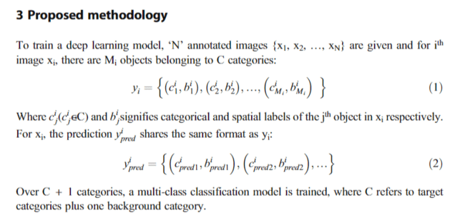

**Summary of the Findings:**

The proposed ensemble model, combining Faster R-CNN and SSD, achieves better results in vehicle detection and traffic density estimation compared to base estimators. It outperforms SSD by 34% and Faster R-CNN by 6% in terms of mean Average Precision (map) on the FLIR thermal dataset.

Detection with thermal images is found to be more effective than visible images for vehicle detection.

Duplicate detections, where the same object is detected in two categories simultaneously, can lead to incorrect results. To address this, an ensemble using a majority voting classifier is implemented, improving the predictions of the base models.

**Future scope:**

Further optimization of the proposed ensemble-based deep learning architecture to improve its running time complexity and computational complexity optimization.

Extension of the model to handle a wider range of vehicle classes and improve the accuracy of vehicle recognition and counting.

Integration of the proposed model with intelligent traffic management systems to optimize signal controllers based on real-time traffic density estimation

Link - <https://link.springer.com/article/10.1007/s11042-022-13659-5>

**2.Traffic Monitoring with Computer Vision**

**Introduction**

Traffic congestion is a growing problem in many urban areas, leading to increased travel times, fuel consumption, and pollution. Traffic monitoring systems play a crucial role in managing traffic flow and implementing effective traffic management strategies. This survey focuses on computer vision-based traffic monitoring systems, analysing existing research and identifying potential areas for further development.

**Proposed Methodology:**

Multi-threaded traffic monitoring system using GMM and connected component labelling for real-time object detection (15-30 fps).

Motion detection with GMM and mask creation using a hybrid algorithm (2-opt heuristic and genetic algorithm) to define the area of interest.

Object detection using connected component labelling with a decision tree and Union-Find data structure.

**Summary of the Findings:**

The paper proposes a computer vision-based traffic monitoring system achieving 72% object detection accuracy and 8.5% false positive rate in real-time (15-30 fps). The system utilizes a GMM for background subtraction and a hybrid algorithm for mask creation to improve motion detection, but limitations like sensitivity to illumination changes remain. Connected component labelling with a decision tree proves effective for object detection. Further research is needed to address limitations and explore functionalities like object classification.

**Future scope:**

The paper proposes improvements for their traffic monitoring system:

Enhance robustness: Address limitations like shadows and occlusions.

Boost accuracy: Explore deep learning for higher detection/classification accuracy.

Expand functionalities: Investigate object classification and license plate recognition.

Link - <https://ieeexplore.ieee.org/document/4956624\>

**3.The Estimation of Traffic Flow Parameters based on Monitoring the Speed Values using Computer Vision**

**Introduction:**

"The Estimation of Traffic Flow Parameters based on Monitoring the Speed Values using Computer Vision" by V. D. Shepelev and colleagues is a comprehensive research effort aimed at enhancing traffic management through the optimization of traffic light signals based on real-time traffic density estimation. The authors explore advanced deep learning technologies, including the Faster R-CNN and Single-shot detector (SSD) models, to achieve accurate vehicle recognition and counting. These models are integral to the development of an ensemble model that outperforms individual base estimators, achieving a maximum mean Average Precision (map) of 94% on the FLIR thermal dataset. This innovative approach demonstrates the potential for significant improvements in traffic flow management by leveraging cutting-edge computer vision techniques.

**Proposed Methodology:**

* The methodology involves real-time vehicle speed determination and its impact on vehicle delay time at signal-controlled intersections.
* The system uses a convolutional neural network (YOLOv3) for vehicle detection and speed determination, capable of identifying and classifying traffic flows into eleven types.
* To accurately track vehicle motion path and speed, the YOLOv3 network is combined with the SORT library, which employs data associations and object state assessment methods.
* Perspective transformation matrices are calculated to determine the distance travelled by vehicles based on changes in latitude and longitude, enabling accurate speed estimation.
* The study identifies two crucial factors related to vehicle queues at intersections: the reduction in free vehicle movement speed due to queue presence and the determination of a queue size that does not hinder intersection crossing dynamics.

**Summary of the Findings:**

The research identified key factors affecting vehicle queues at intersections, including the impact of queue size on free vehicle movement speed, and determining an optimal queue size for efficient intersection crossing. By analysing real-time speed data through computer vision techniques, the study aimed to enhance adaptive traffic light control and signal synchronization, leading to better traffic flow management. Utilizing YOLOv3 for vehicle detection and speed determination, the system successfully classified traffic flows into eleven types and accurately tracked vehicle motion paths. Perspective transformation matrices were used to calculate distances travelled by vehicles, enabling precise speed estimation and assessment of vehicle delay times at signal-controlled intersections. The findings highlight the importance of real-time speed monitoring in improving traffic organization strategies and optimizing intersection operations for smoother traffic flow and reduced vehicle delay times.

**Future scope:**

* Utilizing YOLOv3 for further advancements in real-time vehicle detection and speed determination could enhance the accuracy and efficiency of traffic flow monitoring systems.
* Implementing YOLOv3 in conjunction with advanced machine learning techniques could enable the classification of a wider range of traffic flow types, providing more detailed insights into intersection dynamics and traffic behaviour.
* Integrating YOLOv3 with other computer vision algorithms or sensor technologies may offer a multi-modal approach to traffic monitoring, allowing for more comprehensive data collection and analysis for improved traffic management strategies.
* Exploring the potential of YOLOv3 in developing predictive models for traffic flow patterns and congestion scenarios could lead to proactive measures in optimizing traffic signal control and intersection operations based on anticipated traffic conditions

Link - <https://www.scitepress.org/PublishedPapers/2021/105394/105394.pdf>

**4.Towards Real-time Traffic Flow Estimation using YOLO and SORT from Surveillance Video Footage**

**Introduction:**

The study focuses on leveraging computer vision techniques and CCTV data for real-time traffic flow estimation to address urban traffic challenges. By training the YOLOv4 algorithm and SORT tracker, the research aims to accurately estimate traffic flow rates. This innovative approach has the potential to revolutionize urban planning, traffic infrastructure management, and emergency response systems. Traditional methods like manual counts and inductive loops are labour-intensive and limited, highlighting the need for advanced solutions. The proposed methodology offers a promising avenue for enhancing traffic monitoring and decision-making processes based on real-time traffic flow data.

**Proposed Methodology:**

•The research employs the YOLOv4 algorithm to detect five vehicle classes in low-quality CCTV footage, enabling real-time traffic flow estimation based on movement direction [1].

•Vehicle detection, tracking, and traffic flow estimation are the core components of the methodology, allowing for accurate counting of vehicles by class and direction [2].

•The methodology is adaptable and scalable, making it suitable for various urban environments and complex traffic scenarios, ensuring its practicality and effectiveness [3].

•By utilizing bounding boxes for vehicle localization and tracking their movements across frames, the algorithm facilitates efficient real-time traffic flow estimation and data collection from surveillance video footage [2].

**Summary of the Findings:**

The research paper successfully demonstrates the efficacy of utilizing the YOLOv4 algorithm and the SORT tracker for real-time traffic flow estimation from low-quality surveillance video footage. Custom training of YOLOv4 yielded high performance, achieving an F1-score exceeding 0.95 for car class detection across different times of the day. The methodology accurately counts vehicles and determines traffic flow rates based on movement directions like 'northbound' and 'southbound,' showcasing its adaptability to diverse traffic scenarios. These findings underscore the potential of leveraging computer vision techniques with CCTV data for efficient traffic flow estimation, opening avenues for future studies to explore larger and more diverse datasets encompassing various environmental conditions.

**Future scope:**

* Train the YOLOv4 algorithm with a larger and more diverse dataset to improve accuracy for low-occurring vehicle classes, enhancing overall vehicle detection capabilities.
* Focus on training models on datasets covering various weather and lighting conditions to ensure robust performance in different environments, improving the algorithm's adaptability.
* Refine the algorithm to enable real-time traffic monitoring and analysis, allowing for immediate responses to traffic situations and enhancing overall traffic management efficiency.
* Explore the integration of advanced traffic flow estimation algorithms like YOLOv4 and SORT with smart city infrastructure, enabling more intelligent and data-driven urban planning and traffic management strategies.

Link - <https://www.researchgate.net/publication/353327177_Towards_Real-time_Traffic_Flow_Estimation_using_YOLO_and_SORT_from_Surveillance_Video_Footage>

**Methodology**

1. **Camera Related Properties and Algorithms**

**Resolution:**

Importance: Higher resolution can capture more details, which is essential for identifying subtle differences between fertile and infertile eggs.

Considerations: Balancing between resolution and processing power, as higher resolution images require more computational resources.

**Focus and Depth of Field:**

Importance: Ensures that the entire egg is in focus, particularly the interior structures that are critical for fertility assessment.

Considerations: Use of proper lens and aperture settings to maintain sharp focus across the egg.

**Exposure:**

Importance: Proper exposure settings help in clearly visualizing the internal structures of the egg without overexposure or underexposure.

Considerations: Use of exposure compensation to fine-tune exposure levels based on the brightness of the surroundings.

**Lighting Conditions:**

Importance: Consistent and adequate lighting is essential to visualize the internal features of the egg during candling.

Considerations: Use of ring lights or LED panels to provide uniform illumination.

**White Balance:**

Importance: Corrects color tones to ensure that the images accurately represent the actual appearance of the eggs.

Considerations: Preset white balance modes (e.g., daylight, cloudy, tungsten) or manually setting the white balance based on the specific lighting conditions

**Frame Rate:**

Importance: Determines how quickly images are captured; higher frame rates can be beneficial for real-time processing and analysis.

Considerations: Balancing between frame rate and processing capabilities.

**Image Stabilization:**

Importance: Reduces blurriness caused by camera movement, especially important for handheld or mobile setups.

Considerations: Using optical or digital image stabilization to minimize blurriness caused by camera shake.

**Sensor Sensitivity (ISO):**

Importance: High sensitivity sensors can capture images in low light conditions without excessive noise.

Considerations: Adjusting ISO settings to minimize noise while ensuring adequate brightness.

**Relevant Algorithms**

**Image Enhancement Technique**

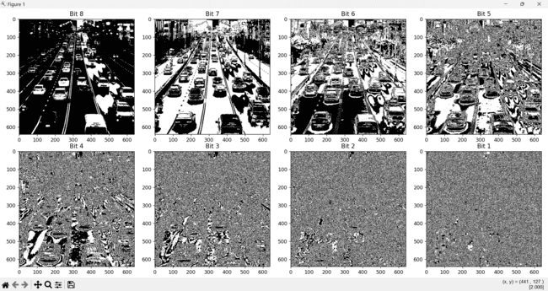

Bit-plane manipulation enhances certain features in images, improving image quality and highlighting detail

**Focus and Depth of Field, Image Segmentation**

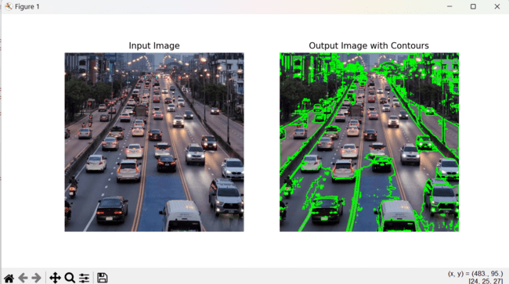

Explanation: Contour detection segments objects, maintaining sharp focus and enabling accurate segmentation.

**Image Augmentation**

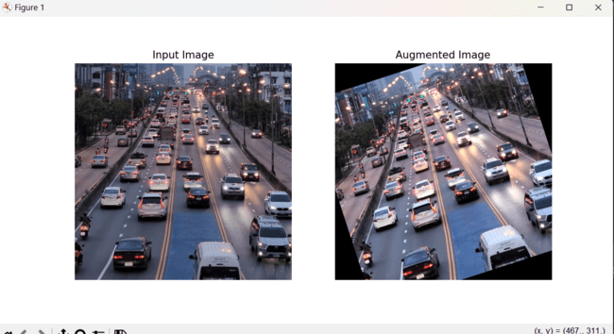

Explanation: Image augmentation generates diverse training data, improving model generalization.

**Perspective Transformation**

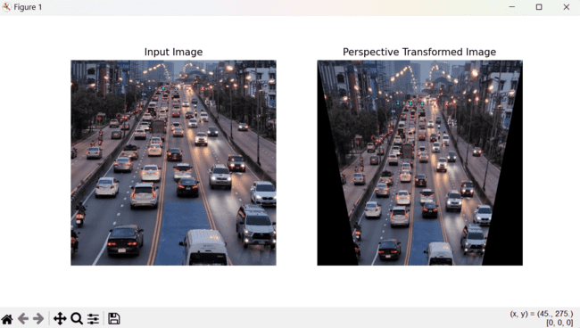

Explanation: Perspective transformation corrects distortions, ensuring accurate measurements.

**Image Segmentation**

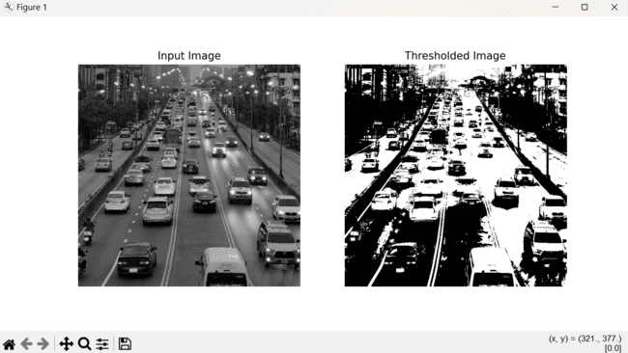

Explanation: Thresholding segments objects, isolating features and enhancing visibility.

**Texture Analysis**

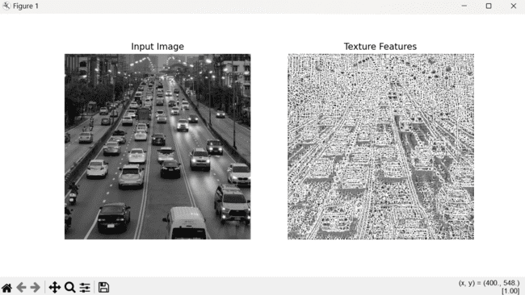

Explanation: Texture analysis identifies and analyzes textures, useful for distinguishing between different features.

**Exposure Control Algorithm**

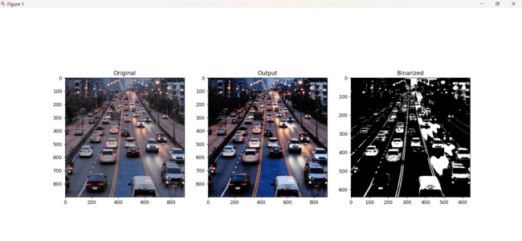

Contrast stretching adjusts the intensity range of an image, optimizing image clarity.

**Image Enhancement Technique**

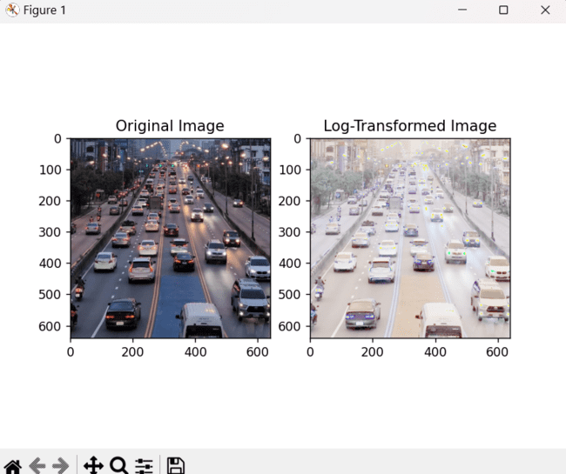

Logarithmic transformation adjusts image dynamic range, enhancing image quality.

**Histogram Analysis**

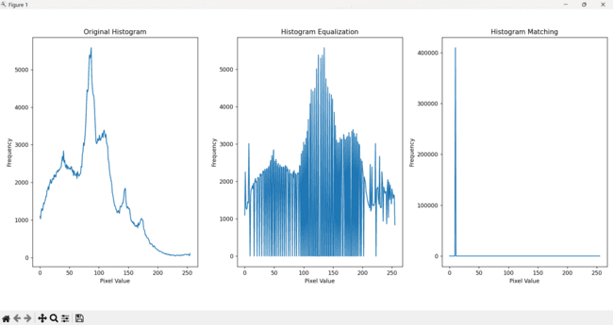

This algorithm analyzes and compares histograms, crucial for understanding pixel intensity distribution

**Histogram Equalization**

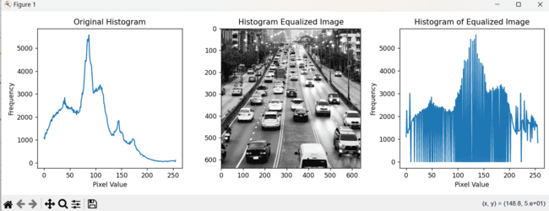

Histogram equalization enhances image contrast, improving visualization of features.

**B. Image Preprocessing techniques:**

**1.Linear Filtering:**

process of image sharpening using convolutional kernels in OpenCV; Convolution is a key operation in image processing, where a kernel (a small matrix) is slid over an image. At each position, an element-wise multiplication is performed between the kernel and the corresponding image pixels, followed by summing these products to produce a single pixel value in the output image. Sharpening involves highlighting edges and fine details in an image, making the image appear crisper.

The sharpening kernel typically has a positive value in the center and negative values around it. This configuration helps to subtract the surrounding pixel values from the central pixel value, effectively enhancing the differences (edges).

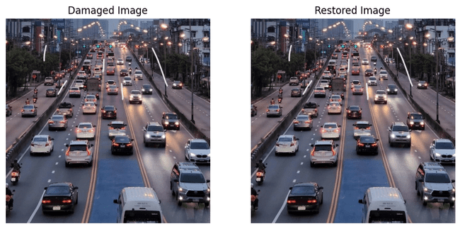

**2.Template Matching with OpenCV**

Template matching is a technique used in image processing to find a smaller image (template) within a larger image. It involves sliding a template image over the larger image and computing a similarity measure at each position. Common similarity measures include correlation, sum of squared differences, and normalized correlation coefficients.

Positions with similarity scores above a specified threshold are considered matches.

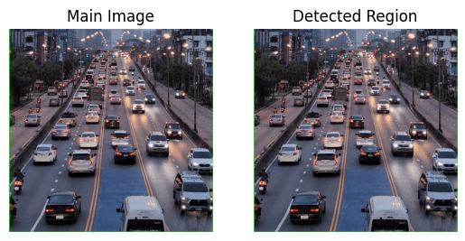

**3. Pixelation Using OpenCV**

Pixelation is an image processing technique where an image is made to appear blocky by reducing its resolution and then scaling it back up to its original size. This effect is often used for obscuring parts of an image for privacy concerns etc.

When reducing the resolution (downscaling), a small version of the original image is created and When increasing the resolution (upscaling), this smaller image is resized back to the original dimensions, resulting in a pixelated effect.

Interpolation is the method used to estimate new pixel values when resizing an image

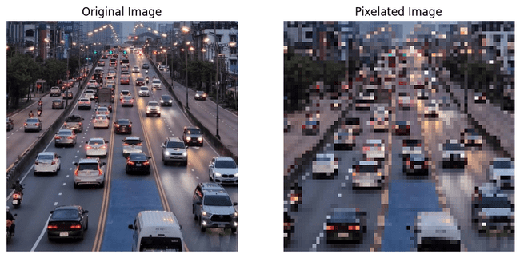

**4.Morphological Closing in Image Processing with OpenCV:**

Morphological operations are a set of image processing techniques that process images based on their shapes. These operations apply a structuring element to an input image to generate an output image, which is particularly useful for removing small holes or gaps in an object.

Images are often converted from one color space to another for easier processing. In this case, the image is converted from BGR to HSV.

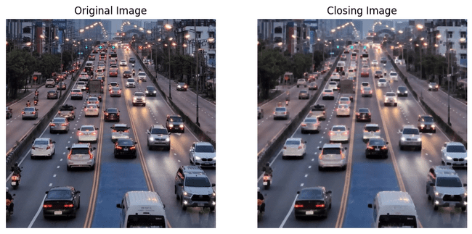

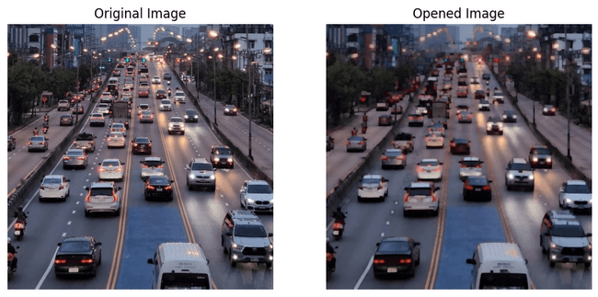

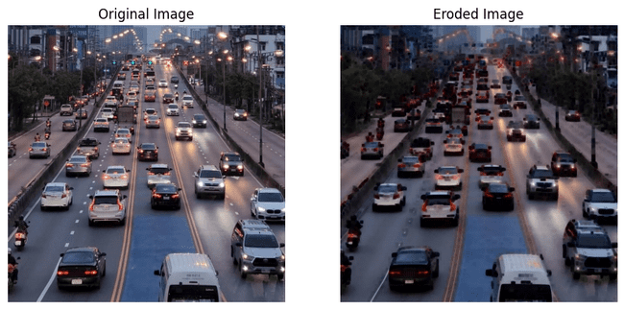

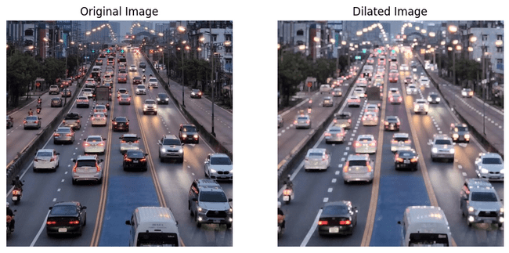

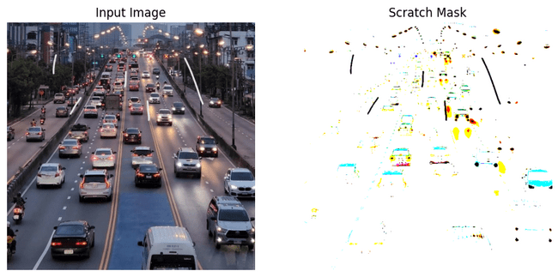



1. **Feature Detection and Matching**

**Feature Detection**

**Definition:**

Feature detection involves identifying distinct and informative points or regions within an image that can be used for further analysis. These points, known as key points, capture essential aspects of the image that are invariant to changes in scale, rotation, and illumination.

**Purpose of Feature Detection in Traffic Density Analyzer**

The primary goal of feature detection in the Traffic Density Analyzer is to identify specific visual cues in road footage that indicate the presence and location of vehicles. These cues might include edges, corners, and textures associated with vehicles. By accurately detecting these features, the system can pinpoint the position of each vehicle within an image or video frame. This facilitates precise vehicle counting, tracking across frames, and ultimately, traffic density estimation.

**Algorithms Implemented:**

1) Harris Corner Detector

2) Differences of Gradients

3) Shi-Tomasi Corner Detection

4) SIFT (Scale-Invariant Feature Transform)

5) SURF (Speeded-Up Robust Features)

6) ORB (Oriented FAST and Rotated BRIEF)

7) FAST (Features from Accelerated Segment Test)

8) BRISK (Binary Robust Invariant Scalable Key points)

9) KAZE

10) AKAZE (Accelerated-KAZE)

**COMPARISON TABLE:**

|  |  |  |  |  |  |
| --- | --- | --- | --- | --- | --- |
| Algorithm | Accuracy | Computational Efficiency | Robustness to Noise | Ease of Implementation | Comments |
| Harris Corner Detector | Medium | Medium | Low-Medium | Easy | Effective for detecting corners, but less robust to noise and variations in scale and rotation. |
| Differences of Gradients | Medium | Medium | Medium | Moderate | Detects edges well, suitable for gradient-based feature detection, moderate robustness to noise. |
| Shi-Tomasi Corner Detection | High | Medium | Medium | Easy | An improvement over Harris, better accuracy for corners, moderate robustness to noise. |
| SIFT (Scale-Invariant Feature Transform) | Very High | Low-Medium | High | Moderate | Highly accurate and robust to scale, rotation, and noise, but computationally intensive. |
| SURF (Speeded-Up Robust Features) | High | Medium | High | Moderate | Faster than SIFT, maintains good accuracy and robustness, suitable for real-time applications. |
| ORB (Oriented FAST and Rotated BRIEF) | High | High | Medium-High | Easy | Efficient and accurate, combines FAST keypoint detector with BRIEF descriptor, good for real-time. |
| FAST (Features from Accelerated Segment Test) | Medium-High | Very High | Low-Medium | Easy | Extremely fast, suitable for real-time applications, less robust to noise and scale variations. |
| BRISK (Binary Robust Invariant Scalable Keypoints) | High | Medium | Medium-High | Moderate | Good accuracy and robustness, faster than SIFT and SURF, suitable for real-time use. |
| KAZE | High | Low-Medium | High | Moderate | Accurate and robust, computationally more demanding, useful for precise feature detection. |
| AKAZE (Accelerated-KAZE) | High | Medium | High | Moderate | Faster version of KAZE, maintains good accuracy and robustness, suitable for real-time use. |

**Comments**:

* For real-time traffic density analysis, **ORB**, **FAST**, and **AKAZE** are preferable due to their high computational efficiency and good accuracy.
* **SIFT** and **SURF** offer very high accuracy and robustness, making them ideal for environments where precision is crucial, though they are more computationally intensive.
* **Shi-Tomasi Corner Detection** is a good balance of accuracy and efficiency, suitable for general applications.
* **BRISK** provides a good trade-off between speed and robustness, making it suitable for real-time scenarios.
* **Harris Corner Detector** and **Differences of Gradients** are simpler and less robust, making them suitable for less demanding applications.

Original Image:

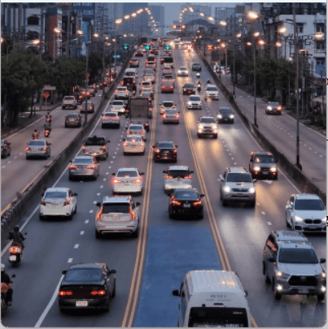

Grayscale Image:

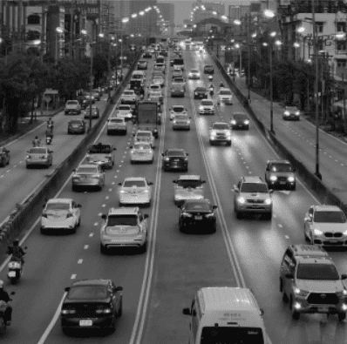

**1.Harris Corner Detector:**

**Approach**: Identifies corners in an image based on variations in intensity.

**Explanation**: Harris Corner Detector calculates the change in intensity for a displacement of (u, v) in all directions. By using the eigenvalues of a covariance matrix constructed from these intensity changes, corners are identified.

**Input**: Grayscale image.

**Output:** Image with marked corners.

**Functionality:** Highlights regions in the image where significant intensity changes occur in all directions, indicative of corners.

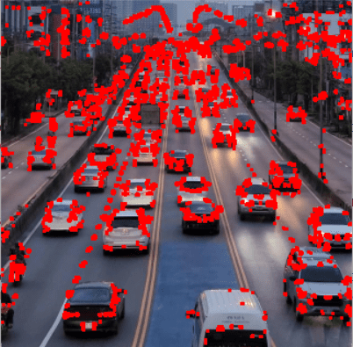

**2.Difference of Gaussians (DoG) Detector:**

**Approach:** Detects key points by computing the difference between two blurred versions of an image.

**Explanation:** It involves convolving the image with two different Gaussian filters and then taking the difference of these blurred images. This process highlights regions with significant intensity changes.

**Input:** Grayscale image.

**Output:** Image highlighting key points.

**Functionality:** Identifies regions with significant changes in intensity, often corresponding to key points such as edges and corners.

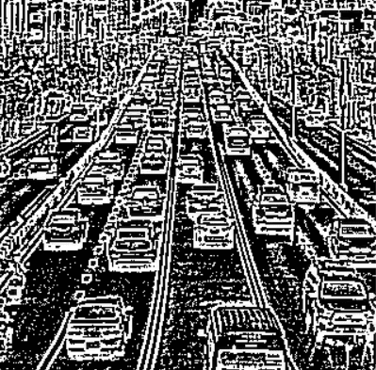

**3.MSER Detector:**

**Approach:** Detects regions of maximally stable extremal regions.

**Explanation:** MSER detects regions that remain stable over varying thresholds of intensity. These regions are typically blob-like structures.

**Input:** Grayscale image.

**Output:** Image with detected regions highlighted.

**Functionality:** Identifies stable regions in the image, robust to changes in illumination and noise.

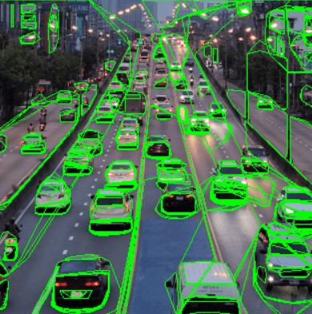

**4. Shi-Tomasi Corner Detection:**

**Approach:** An improvement over the Harris Corner Detector, using the minimum eigenvalue instead of the harmonic mean of eigenvalues.

**Explanation:** It selects corners based on a scoring function that considers both the minimum eigenvalue of the autocorrelation matrix and the distance between neighbouring corners.

**Input:** Grayscale image.

**Output:** Image with detected corners marked.

**Functionality:** Detects corners based on local variations in intensity, more efficiently than the Harris Corner Detector.

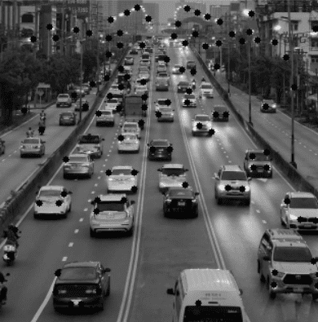

**5.SIFT Detector:**

**Approach:** Identifies key points based on scale-space extrema in the Difference of Gaussians pyramid.

**Explanation:** SIFT detects stable key points across different scales and rotations by constructing a scale-space representation of the image and identifying extremal points in this space.

**Input:** Grayscale image.

**Output:** Image with detected key points.

**Functionality:** Locates distinctive features in the image invariant to scale, rotation, and illumination changes.

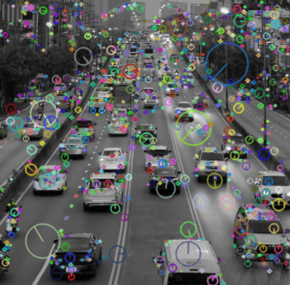

**6. FAST Detector:**

**Approach:** Uses a high-speed corner detection algorithm.

**Explanation:** FAST identifies corners by comparing the intensity of pixels in a circular pattern around a central pixel. It is a high-speed algorithm designed for real-time applications.

**Input:** Grayscale image.

**Output:** Image with detected corners.

**Functionality:** Quickly identifies corners in the image, suitable for real-time applications.

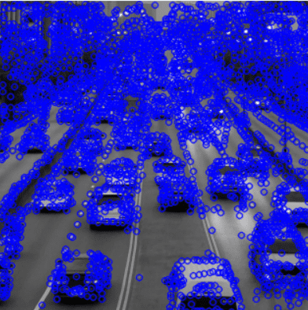

**7. ORB Detector:**

**Approach:** Combines aspects of FAST key point detector and BRIEF descriptor.

**Explanation:** ORB detects key points using FAST and computes descriptors using BRIEF. It's efficient and offers good performance.

**Input:** Grayscale image.

**Output:** Image with detected key points.

**Functionality:** Provides a fast and efficient method for key point detection and description.

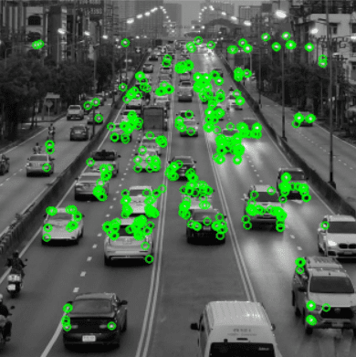

**8. BRISK Detector:**

**Approach:** Uses a scale-space FAST detector combined with a modified version of the binary robust independent elementary features (BRIEF) descriptor.

**Explanation:** BRISK detects key points in scale-space using FAST and generates descriptors using a modified version of BRIEF, which is more robust to scale and rotation changes.

**Input:** Grayscale image.

**Output:** Image with detected key points.

**Functionality:** Provides a robust and efficient method for detecting key points invariant to scale and rotation changes.

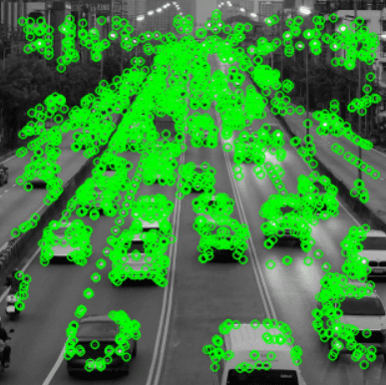

**9. KAZE Detector:**

**Approach:** Detects key points using nonlinear scale space.

**Explanation:** KAZE detects key points by analysing nonlinear scale space representations of the image. It is designed to be more robust to nonlinear image transformations.

**Input:** Grayscale image.

**Output:** Image with detected key points.

**Functionality:** Provides robust key point detection, particularly in images with nonlinear transformations.

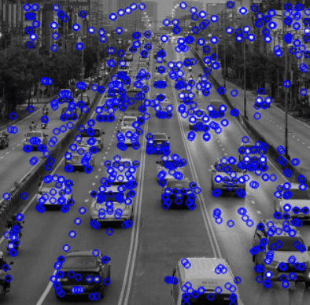

**10.AKAZE Detector:**

**Approach:** An improvement over KAZE, with additional descriptors for improved matching.

**Explanation:** AKAZE enhances KAZE by introducing additional descriptors that improve the matching process, particularly in challenging conditions.

**Input:** Grayscale image.

**Output:** Image with detected key points.

**Functionality:** Provides robust key point detection and improved matching performance, particularly in challenging conditions.

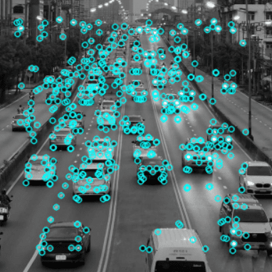

**Feature Matching Algorithms:**

**Definition:**

Feature matching involves finding correspondence between features detected in different images. The objective is to identify and link key points from one image to another, facilitating tasks such as object recognition, image alignment, and 3D reconstruction.

**Purpose of Feature Matching in Traffic Density Analyzer**

The aim of feature matching in the Traffic Density Analyzer is to compare features across multiple images or video frames to verify consistent patterns that indicate the presence and movement of vehicles. By matching detected features such as edges, corners, and textures from one frame to another, the system can accurately track the same vehicle over time

**Algorithms Implemented:**

1) Brute-Force Matcher:

2) FLANN (Fast Library for Approximate Nearest Neighbours):

3) BFMatcher with Cross-Check:

4) RANSAC Matcher:

5) FLANN-Based Matcher:

6) KNN Matcher:

7) Radius Matcher:

8) Ratio Matcher:

9) Cross-Check Matcher:

10) Brute-Force Cross-Check Matcher

**COMPARISON TABLE:**

|  |  |  |  |  |  |
| --- | --- | --- | --- | --- | --- |
| Algorithm | Accuracy | Computational Efficiency | Robustness to Noise | Ease of Implementation | Comments |
| Brute-Force Matcher | High | Low | Medium | Easy | Accurate but computationally expensive; not ideal for real-time applications. |
| FLANN | Medium-High | High | Medium | Moderate | Efficient for large datasets, good balance of speed and accuracy, suitable for real-time use. |
| BFMatcher with Cross-Check | High | Medium | High | Moderate | Enhances accuracy by cross-checking matches, more robust but slightly more computationally demanding. |
| RANSAC Matcher | High | Medium | Very High | Moderate | Very robust to noise and outliers, ideal for ensuring reliable matches, computational cost can vary. |
| FLANN-Based Matcher | Medium-High | High | Medium | Moderate | Similar to FLANN, balances speed and accuracy, suitable for large datasets and real-time analysis. |
| KNN Matcher | Medium | Medium | Medium | Moderate | Good for finding multiple potential matches, can be combined with ratio test for better results. |
| Radius Matcher | Medium | Medium | Medium | Moderate | Useful for specific scenarios where a match within a certain distance is required. |
| Ratio Matcher | High | Medium | High | Moderate | Improves match quality by applying a ratio test, balancing accuracy and computational efficiency. |
| Cross-Check Matcher | High | Medium | High | Moderate | Ensures bidirectional consistency, improving reliability of matches, slightly more demanding computationally. |
| Brute-Force Cross-Check Matcher | High | Low | High | Moderate | Very accurate with cross-checking but computationally expensive, not ideal for real-time use. |

**Comments**:

* For real-time traffic density analysis, **FLANN** and **FLANN-Based Matcher** are preferable due to their high computational efficiency and good accuracy.
* **RANSAC Matcher** is highly robust to noise, making it ideal for environments with high variability or occlusions.
* **BFMatcher with Cross-Check** and **Cross-Check Matcher** provide a good balance between accuracy and robustness, suitable for environments where accuracy is crucial.
* **Brute-Force Matcher** and **Brute-Force Cross-Check Matcher** offer high accuracy but are computationally intensive, making them less suitable for real-time applications.

**1. Brute-Force Matcher:**

**Approach:** Matches features by comparing every feature in the first set to every feature in the second set.

**Explanation:** It computes the distance between every pair of descriptors and matches those with the smallest distance.

**Input:** Descriptors of features from two images.

**Output:** Matches between features.

**Functionality:** Provides a simple but exhaustive method for feature matching.

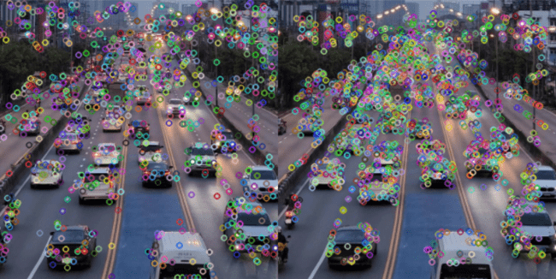

**2.FLANN Matcher:**

**Approach:** Utilizes the FLANN (Fast Library for Approximate Nearest Neighbors) algorithm for efficient matching.

**Explanation:** FLANN Matcher approximates the nearest neighbors using efficient data structures, improving matching speed.

**Input:** Descriptors of features from two images.

**Output:** Matches between features.

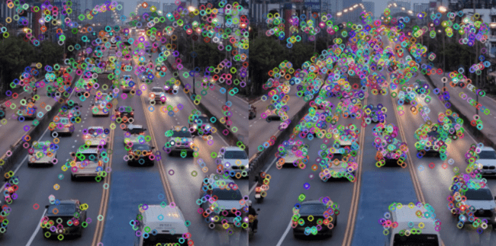

**3. Brute-Force Matcher with Cross-Checking:**

**Approach:** Matches features using a brute-force approach with cross-checking.

**Explanation:** It matches features from both images, but then checks if the match is mutual (i.e., a feature from the first image matches a feature from the second image and vice versa).

**Input:** Descriptors of features from two images.

**Output:** Matches between features.

**Functionality:** Reduces false positives by ensuring mutual matches between features from both images.

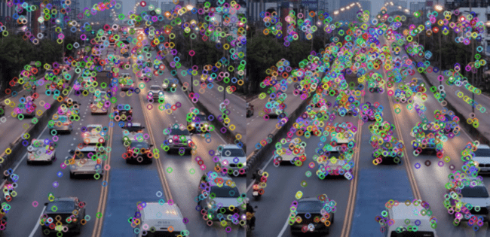

**4. FLANN-Based Matcher:**

**Approach:** Similar to FLANN Matcher but with more control over parameters.

**Explanation:** FLANN-Based Matcher utilizes FLANN but provides more control over parameters such as the algorithm used and the number of trees.

**Input:** Descriptors of features from two images.

**Output:** Matches between features.

**Functionality:** Offers improved performance and flexibility compared to the basic FLANN Matcher.

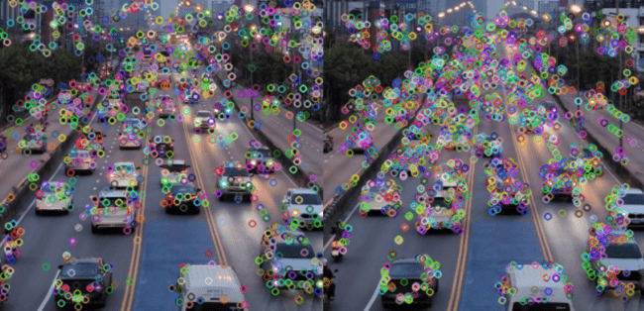

**5.K-Nearest Neighbors (KNN) Matcher:**

**Approach:** Matches features by comparing each feature in one set to the k-nearest neighbours in the other set.

**Explanation:** It finds the k-nearest neighbours of each feature in one set within the other set and considers matches with the smallest distance as potential matches.

**Input:** Descriptors of features from two images.

**Output:** Matches between features.

**Functionality:** Provides more flexibility in matching by considering multiple potential matches for each feature.

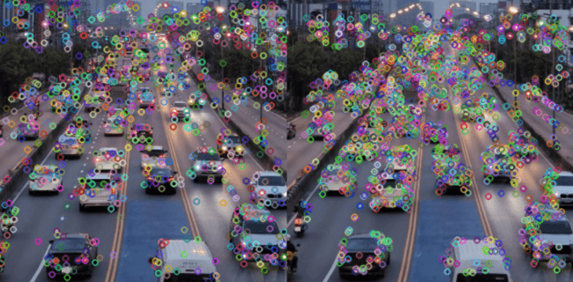

**6. Radius Matcher:**

**Approach:** Matches features within a certain radius of each other.

**Explanation:** It finds matches between features from both images where the distance between their descriptors is within a specified radius.

**Input:** Descriptors of features from two images.

**Output:** Matches between features.

**Functionality:** Allows for matching features that are within a specified distance of each other, useful for cases where the exact match is not necessary

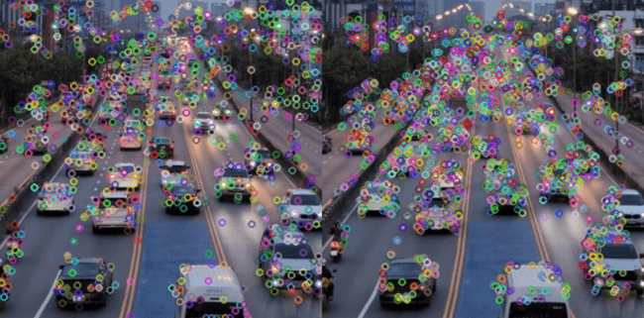

**7. Ratio Matcher:**

**Approach:** Matches features by comparing the ratio of distances between the best and second-best matches.

**Explanation:** It considers a match valid if the distance to the best match is significantly smaller than the distance to the second-best match.

**Input:** Descriptors of features from two images.

**Output:** Matches between features.

**Functionality:** Reduces false positives by considering the ratio of distances, providing more robust matching.

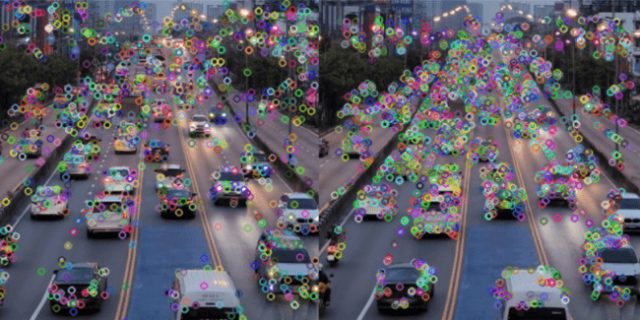

**8. Cross-Check Matcher:**

**Approach:** Matches features by checking for mutual matches between both images.

**Explanation:** It matches features from both images and then checks if the match is mutual, i.e., a feature from the first image matches a feature from the second image and vice versa.

**Input:** Descriptors of features from two images.

**Output:** Matches between features.

**Functionality:** Ensures mutual matches between features from both images, reducing false positives.

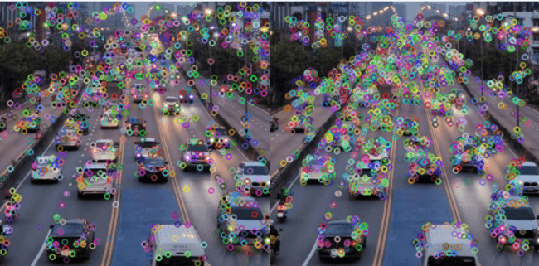

**9.RANSAC Matcher:**

**Approach:** Matches features using the Random Sample Consensus (RANSAC) algorithm to find the best transformation model.

**Explanation:** It uses RANSAC to estimate the transformation model (e.g., affine or perspective) between the matched features and removes outliers.

**Input:** Descriptors of features from two images, keypoints from both images, and a mask to indicate inliers.

**Output:** Inliers indicating valid matches.

**Functionality:** Robustly estimates the transformation model between images, particularly in the presence of outliers or mismatches.

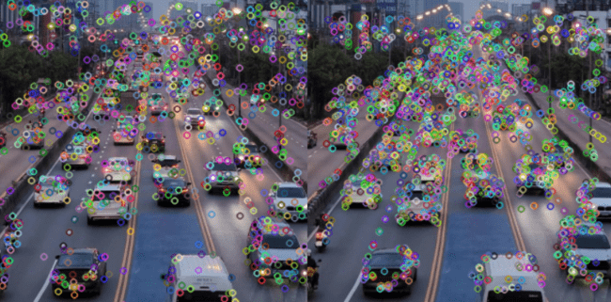

**10. Brute-Force Cross-Check Matcher:**

**Approach:** Matches features by ensuring mutual matching between two sets of descriptors using the brute-force method.

**Explanation:** This algorithm matches descriptors from two images in both directions and retains only the matches that are mutual.

**Input:** Descriptors of features from two images.

**Output:** A list of good matches that passed the mutual matching check.

**Functionality:** Ensures robust feature matching by performing bidirectional matching and retaining only mutually agreed-upon matches. This reduces false positives and enhances matching accuracy.

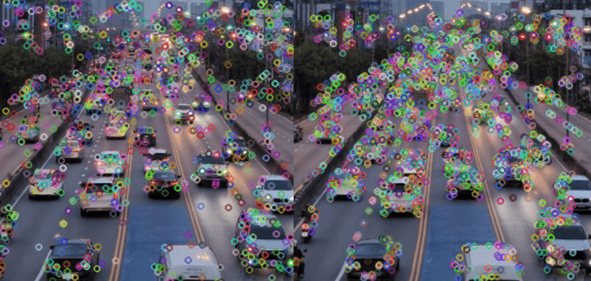

1. **Video Processing Concepts**

**Key Frame extraction**

**Purpose:**

Keyframe extraction involves identifying and selecting the most representative frames from a video sequence. This reduces the amount of data to process while retaining essential information for analysis.

The methods implemented are:

1.Frame Sampling

2.Scene change detection

3.Clustering based keyframe extraction

4.Deep Learning based keyframe extraction

**COMPARISON TABLE:**

|  |  |  |  |  |  |
| --- | --- | --- | --- | --- | --- |
| Method | Accuracy | Computational Efficiency | Robustness to Varying Conditions | Ease of Implementation | Comments |
| Frame Sampling | Low-Medium | Very High | Low-Medium | Very Easy | Simplest method, selects frames at regular intervals, may miss critical events or changes in traffic. |
| Scene Change Detection | High | Medium | High | Moderate | Detects significant changes in the scene, effective for capturing dynamic traffic events, moderately efficient. |
| Clustering Based Keyframe Extraction | High | Medium | High | Moderate | Groups similar frames and selects representative ones, captures diverse traffic conditions well, computationally moderate. |
| Deep Learning Based Keyframe Extraction | Very High | Medium-Low | Very High | Difficult | Most accurate, leverages deep learning models to identify keyframes, highly robust but computationally intensive. |

**Comments**:

* **Frame Sampling** is very efficient and easy to implement, suitable for basic applications where computational resources are limited, but may not capture critical traffic changes accurately.
* **Scene Change Detection** provides a good balance of accuracy and efficiency, ideal for environments with frequent and significant changes in traffic conditions.
* **Clustering Based Keyframe Extraction** is effective in capturing a wide range of traffic scenarios by grouping similar frames, suitable for moderate to high traffic variability.
* **Deep Learning Based Keyframe Extraction** offers the highest accuracy and robustness, making it ideal for applications requiring detailed and precise analysis of traffic patterns, though it requires substantial computational resources and implementation effort.

### **1. Frame Sampling**

**Method**: Frame Sampling extracts frames at regular intervals throughout the video.

**Explanation**:

* This is the simplest method for keyframe extraction.
* Frames are selected based on a fixed interval, meaning every nth frame is chosen as a keyframe.
* This method does not consider the content of the frames, so it might miss important changes or events in the video.

**Pros**:

* Easy to implement and computationally inexpensive.
* Useful for videos with uniform content where changes are predictable.

**Cons**:

* Not suitable for videos with significant variations or important scenes occurring at irregular intervals.
* Can result in redundant keyframes if the video content is highly repetitive.

**Results:**

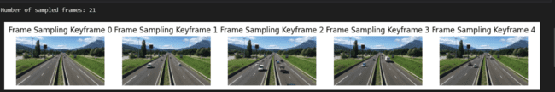

### **2. Scene Change Detection**

**Method**: Scene Change Detection identifies keyframes based on changes in the color histograms between consecutive frames.

**Explanation**:

* This method calculates the color histogram for each frame and compares it to the previous frame.
* If the difference exceeds a certain threshold, the frame is considered a keyframe, indicating a significant scene change.
* The comparison is often done using histogram comparison metrics like Chi-Square, Intersection, Bhattacharyya distance, etc.

**Pros**:

* Effective for videos with distinct scene changes.
* Ensures that each keyframe represents a different scene.

**Cons**:

* Computationally more expensive than frame sampling.
* The choice of threshold is crucial and can affect the accuracy of keyframe detection.

**Results:**

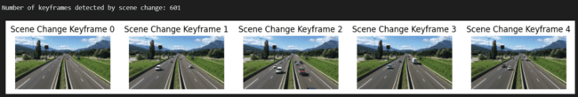

### **3. Clustering-based Keyframe Extraction**

**Method**: Clustering-based extraction uses clustering algorithms (e.g., K-Means) to group similar frames and select representative frames from each cluster.

**Explanation**:

* Frames are converted into feature vectors (e.g., resized and flattened).
* A clustering algorithm groups these vectors into a predefined number of clusters.
* The centroid of each cluster represents a group of similar frames, and the frame closest to each centroid is chosen as a keyframe.

**Pros**:

* Captures the diversity of scenes in the video.
* Ensures that keyframes are representative of different segments of the video.

**Cons**:

* Requires selecting the number of clusters, which might be non-trivial.
* Computationally more intensive due to the clustering process.

**Results:**

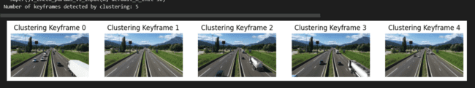

### 4. Deep Learning-based Keyframe Extraction

**Method**: Deep Learning-based extraction uses a pre-trained deep learning model to extract features from frames and identify keyframes based on visual content.

**Explanation**:

* A deep learning model (e.g., VGG16) pre-trained on a large dataset is used to extract high-level features from each frame.
* The features are compared to find frames that are significantly different from the mean feature vector.
* Frames with the largest differences (i.e., highest distances from the mean) are selected as keyframes.

**Pros**:

* Leverages powerful feature extraction capabilities of deep learning models.
* Effective at identifying visually distinct and important frames.

**Cons**:

* Requires significant computational resources, especially for feature extraction.
* Dependent on the choice of the pre-trained model and the threshold for keyframe selection.

**Results:**



**Optical Flow Algorithm**

**Purpose :**

The purpose of integrating an optical flow algorithm could be to accurately track the movement of vehicles or other objects within the road footage captured by the camera. By applying optical flow, you can precisely estimate the motion vectors of various elements in consecutive frames of the video

**Original Video Frame:**

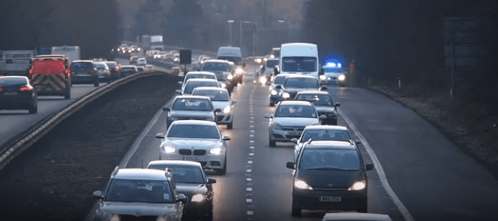

**COMPARISON TABLE:**

|  |  |  |  |  |  |  |
| --- | --- | --- | --- | --- | --- | --- |
| Algorithm | Type | Accuracy | Computational Efficiency | Robustness to Varying Conditions | Ease of Implementation | Comments |
| Lucas-Kanade Algorithm | Sparse | High | High | Medium-High | Easy | Effective for tracking specific points, high efficiency, suitable for real-time applications. |
| Horn-Schunck Algorithm | Sparse | High | Low-Medium | High | Moderate | Provides a global motion estimation, robust to noise, but computationally intensive. |
| Farneback Algorithm | Dense | High | Medium | High | Moderate | Estimates dense motion fields, suitable for capturing detailed motion, moderately efficient. |
| Lucas-Kanade (Dense) Algorithm | Dense | High | Medium | High | Moderate | Extends Lucas-Kanade to dense flow, providing detailed motion information, good balance of accuracy and efficiency. |

**Comments**:

* **Lucas-Kanade Algorithm (Sparse)** is highly efficient and easy to implement, making it ideal for real-time applications where tracking specific points is sufficient.
* **Horn-Schunck Algorithm** offers high accuracy and robustness to noise, suitable for applications requiring global motion estimation, though it is more computationally demanding.
* **Farneback Algorithm** provides detailed dense motion fields, capturing fine motion details, suitable for environments with complex traffic patterns, with moderate computational demands.
* **Lucas-Kanade (Dense) Algorithm** extends the sparse version to dense motion estimation, balancing accuracy and computational efficiency, suitable for detailed traffic analysis.

**Sparse Optical Flow**

**1.Lucas -Kanade Algorithm**

The Lucas-Kanade algorithm is a widely used method in computer vision for optical flow estimation, particularly in scenarios with small motion between consecutive frames, such as the movement of vehicles in traffic footage. It operates by assuming that the pixel intensities do not change significantly between neighboring frames within a small local region. By selecting a set of key points or features in the reference frame and tracking their movement in subsequent frames, the algorithm computes the apparent motion vectors (velocity) of these points

**Purpose :**

The Lucas-Kanade algorithm is utilized in traffic density analysis to estimate the motion of vehicles in consecutive frames, aiding in vehicle tracking and speed estimation for traffic flow analysis and congestion detection.

**Result :**

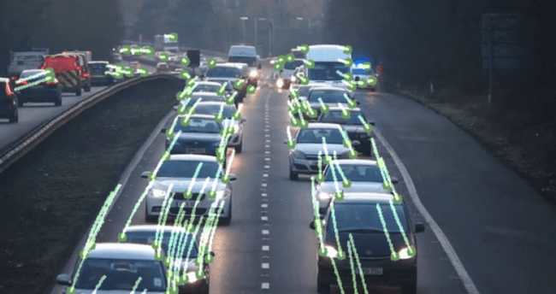

**2.** **Horn-Schunck Algorithm:**

**Summary:** The Horn-Schunck algorithm is an optical flow algorithm used to estimate the motion field between consecutive frames by minimizing the difference in intensity gradients.

**Application:** In traffic density analysis, Horn-Schunck can be applied to detect and track the movement of vehicles in video footage, providing insights into vehicle speed, traffic flow patterns, and congestion

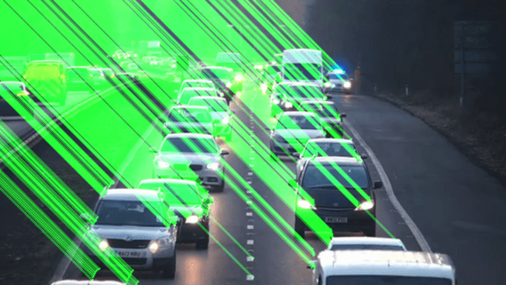

**Dense Optical Flow**

**1.** **Farneback Algorithm:**

**Summary:** Farneback algorithm computes dense optical flow by approximating local polynomial expansions around each pixel.

**Purpose:** Farneback algorithm is utilized to compute dense optical flow, offering detailed motion estimation across the entire image. In traffic density analysis, it facilitates precise tracking of vehicle movements, lane-level monitoring, and the detection of flow patterns, aiding in traffic flow analysis and congestion detection.

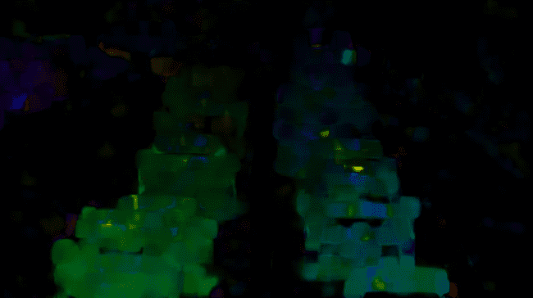

**2. Lucas-Kanade (Dense) Algorithm:**

**Summary:** Lucas-Kanade dense optical flow algorithm estimates the motion of every pixel in consecutive frames by solving a system of linear equations.

**Purpose:** The Lucas-Kanade dense optical flow algorithm serves to estimate motion at every pixel in consecutive frames. Specifically in traffic density analysis, it enables pixel-level tracking of vehicles, accurate speed estimation, and detailed flow analysis, essential for real-time traffic monitoring, congestion detection, and traffic management.

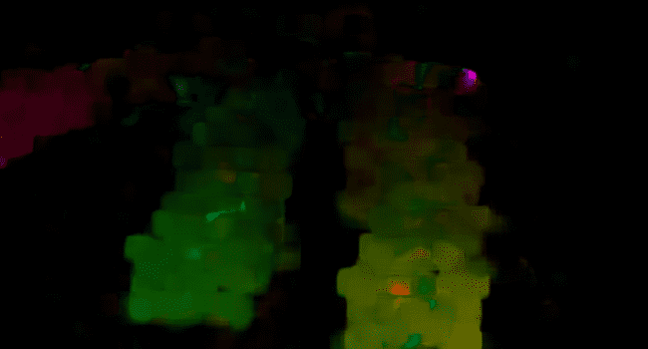

**Classifiers for recognition**

**Haar cascade:**

Input: Use a video processing library like OpenCV to read the input video file.

Initialize the Haar cascade classifier: Load a pre-trained Haar cascade classifier for the object you want to detect (e.g., cars). You can use the pre-trained XML files provided by OpenCV or train your own cascade classifier.

Process each frame: Iterate through each frame of the video.

Convert the frame to grayscale: Convert each frame to grayscale, as Haar cascades typically work with grayscale images.

Detect objects in the frame: Apply the Haar cascade classifier to detect objects (e.g., cars) in the grayscale frame using the detect Multiscale function.

Draw bounding boxes: If objects are detected, draw bounding boxes around them on the original colour frame.

Display or save the annotated video: Optionally, display the annotated video in real-time or save it to a new video file.

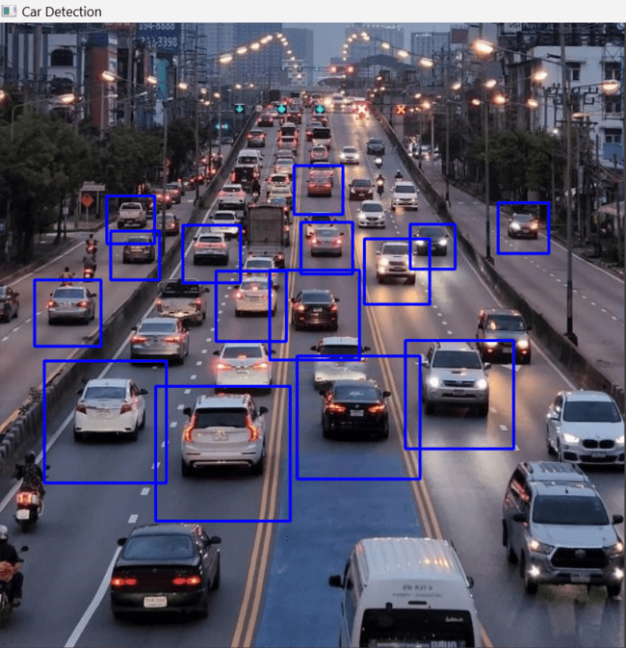

**HOG:**

Histogram of Oriented Gradients (HOG) is commonly used for car detection and other object detection tasks due to several reasons:

**Robustness to Variations in Appearance**: HOG features capture the local gradient information of an image, making them robust to variations in illumination, scale, and orientation. This allows HOG-based detectors to effectively detect objects under different lighting conditions and viewpoints.

**Descriptor of Local Texture and Shape:** HOG features encode information about local texture and shape characteristics of objects in an image. This makes them particularly suitable for detecting objects with distinctive visual patterns, such as cars with their characteristic edges and contours.

**Efficient Representation:** HOG features provide a compact and efficient representation of the visual appearance of objects in an image. This makes them computationally efficient to compute and process, making HOG-based detectors suitable for real-time applications.

**Well-established Technique:** HOG-based object detection has been extensively studied and proven effective in various applications, including pedestrian detection, face detection, and, importantly, car detection. It has become a standard feature descriptor for many object detection algorithms.

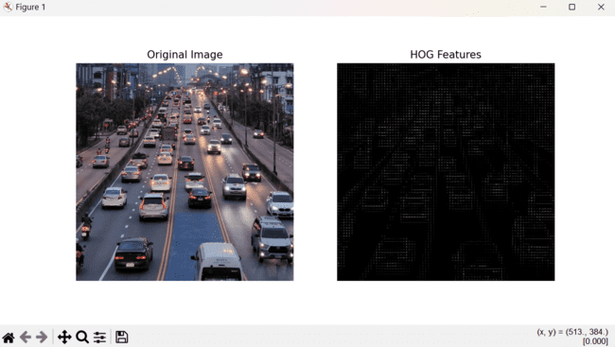

**Results (Yolo Implementation):**

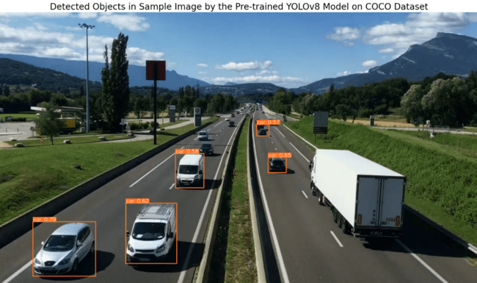

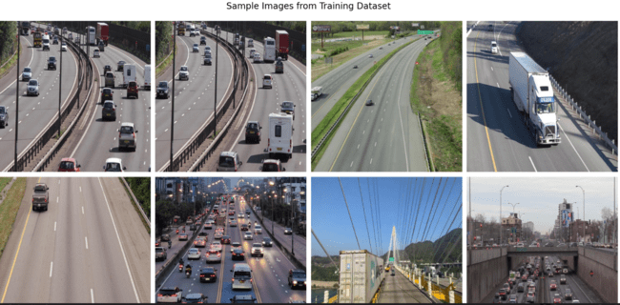

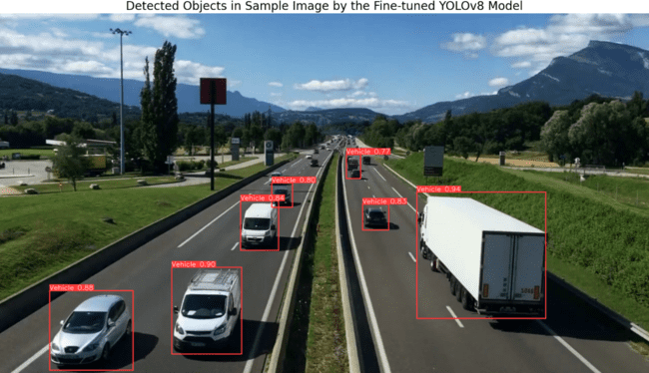

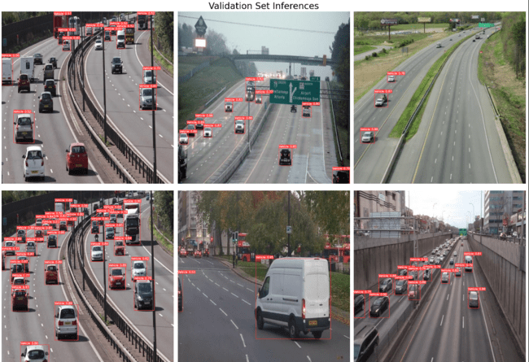

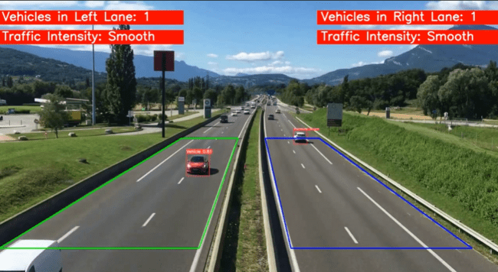

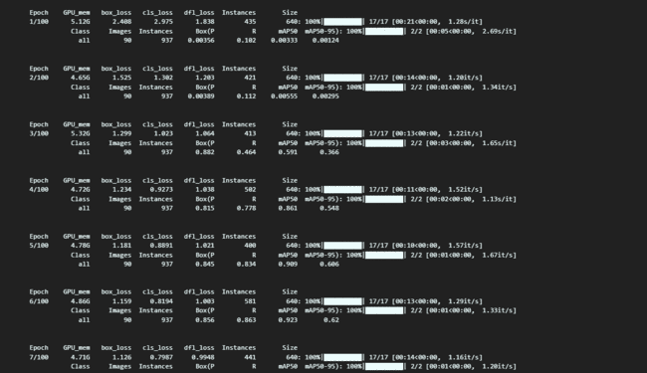

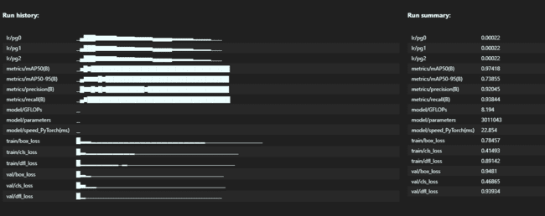

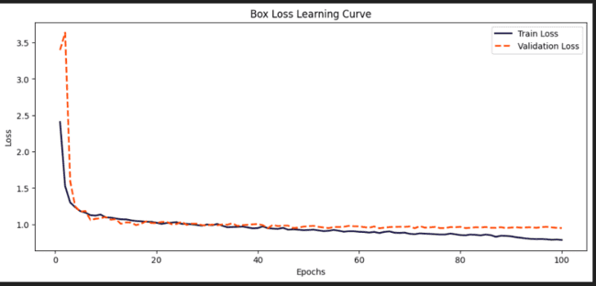

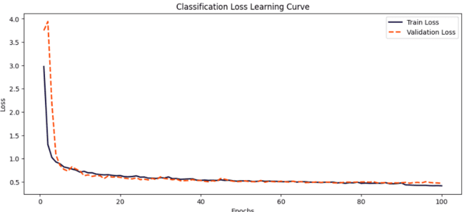

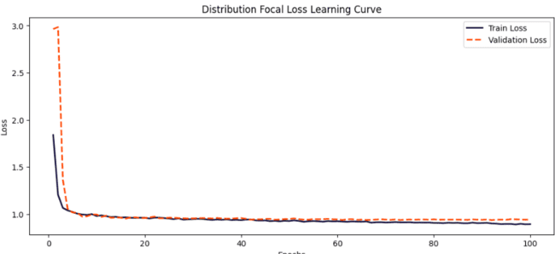

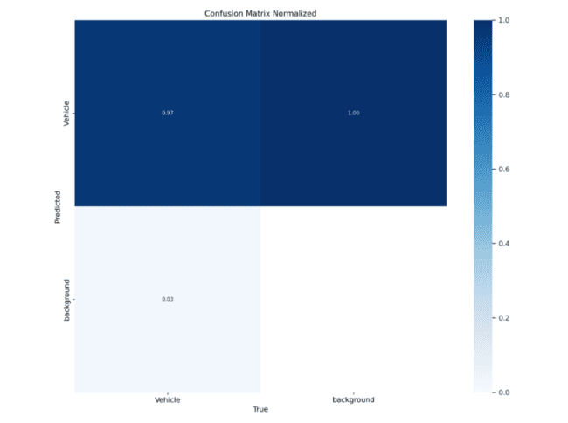

**Performance metrics:**

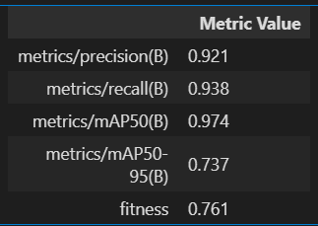

**Conclusion:**

In our project, we successfully developed a Traffic Density Analyzer using advanced computer vision techniques, specifically leveraging the YOLO (You Only Look Once) model. This approach allowed us to accurately detect and count vehicles in real-time, providing a reliable measure of traffic density.

The project demonstrates the potential of integrating computer vision algorithms to address practical problems in traffic management. By utilizing YOLO, a state-of-the-art object detection algorithm known for its speed and accuracy, we were able to process video feeds efficiently and generate real-time insights into traffic conditions.

**Key Contributions:**

Computer Vision Integration: Our system integrates cutting-edge computer vision methodologies to analyze traffic density. The use of YOLO enables the detection of multiple vehicle types with high precision, ensuring robust performance even in complex and dynamic environments.

**Algorithmic Implementation**: The YOLO algorithm, known for its real-time object detection capabilities, was pivotal to our project's success. YOLO's architecture, which processes images in a single pass using a convolutional neural network (CNN), allowed for rapid and accurate vehicle detection. This efficiency is crucial for real-time traffic monitoring applications.

**Real-Time Processing:** One of the significant achievements of this project is the ability to process and analyze video streams in real-time. The high processing speed of YOLO, combined with our optimized implementation, ensures that traffic density data is updated continuously, providing timely information for traffic management and control systems.

**Scalability and Adaptability**: The system is designed to be scalable and adaptable to different traffic environments. By retraining the YOLO model with domain-specific datasets, the Traffic Density Analyzer can be tailored to various urban settings, addressing unique traffic patterns and challenges.

In conclusion, our Traffic Density Analyzer showcases the practical application of computer vision techniques in addressing real-world problems. The successful implementation of the YOLO model underscores the efficacy of modern object detection algorithms in providing accurate and timely traffic data. This project not only highlights the potential for technological innovation in traffic management but also sets the stage for future advancements in smart city infrastructure and autonomous vehicle navigation.